

ARTIFICIAL INTELLIGENCE
NLP Based Agentic AI | Analyzing Amazon Customer Reviews

CSC – 471
Professor Qurat Ul Ain Aini

Program:
BSCS

Assignment:
03

Submission date:
14-January-2026

Table of Contents
1. INTRODUCTION 4
2. DATASET DESCRIPTION 4
3. NLP TASKS IMPLEMENTED 4
3.1 Sentiment Analysis 4
3.2 Text Summarization 4
4. MODELS USED 5
5. EVALUATION 5
6. AGENTIC AI DESIGN 5
6.1 System Architecture 5
7. DECISION-MAKING PROCESS 5
8. INTEGRATED SYSTEM 6
8.1 Example 1 6
8.2 Example 2 6
9. DISCUSSION 6
10. CONCLUSION 6
11. IMPLEMENTATION AND RESULTS 7

Table of Figures
Figure 1: Loading CSV Dataset 7
Figure 2: Loading NLP Models 7
Figure 3: Agent Running on One Review 7
Figure 4: Evaluation Results 8
Figure 5: Interactions of Multiple Agents 8

1. INTRODUCTION
In recent years, Artificial Intelligence has improved a lot, especially in the field of Natural Language Processing (NLP). Earlier, NLP systems were mostly designed to perform only one task at a time, such as classifying text or generating summaries. However, modern AI systems are becoming more advanced and are now able to understand user goals, decide what actions to take, and use different tools automatically. These systems are known as Agentic AI systems.
The purpose of this assignment is to design and demonstrate an NLP-based Agentic AI system. The system is able to read customer reviews, analyze their sentiment, summarize the text, and make decisions about which tasks to perform based on the input.

2. DATASET DESCRIPTION
For this project, an Amazon customer reviews dataset in CSV format was used. The dataset contains real reviews written by customers along with their product ratings. Each record includes:
- Review text
- Rating from 1 to 5 stars
This dataset was selected because it represents real-world user opinions and is widely used for NLP tasks such as sentiment analysis and text summarization.

3. NLP TASKS IMPLEMENTED
Two main NLP tasks were implemented in this project.

3.1 Sentiment Analysis
Sentiment analysis is used to determine whether a review expresses a positive, negative, or neutral opinion. Reviews with high ratings (4 or 5) are considered positive, low ratings (1 or 2) are considered negative, and middle ratings are treated as neutral.
Example: “The phone is good but the battery life is short.”
Output: Neutral

3.2 Text Summarization
Text summarization is used to reduce long reviews into shorter versions while keeping the main idea. This helps users quickly understand the important points of a review.
Example: “The laptop is fast and reliable but the screen quality is not very good.”
Output: “The laptop is fast but has poor screen quality.”

4. MODELS USED
Pre-trained transformer models were used for both NLP tasks:
- A transformer model for sentiment analysis
- A transformer model for text summarization
These models were loaded using a Python NLP library and allowed the system to perform accurate analysis without training models from scratch.

5. EVALUATION
The sentiment model was evaluated using common performance metrics such as accuracy and F1-score. The results showed that the model was able to correctly classify most reviews. The summarization model was evaluated using ROUGE scores, which measure how well the generated summary matches the original text.
Overall, the models performed well on the Amazon reviews dataset.

6. AGENTIC AI DESIGN

6.1 System Architecture
The Agentic AI system consists of the following parts:
- Perception Layer – reads and understands the input text
- Planner – decides which actions are needed
- Memory – stores intermediate results
- Action Module – runs NLP tools
- Output Layer – provides the final response
The system works in a loop where the user input is first understood, then actions are planned, tools are executed, and the final result is returned.

7. DECISION-MAKING PROCESS
When a user provides a review, the system first checks its length and content. If the text is long, the system selects the summarization tool. If the text contains opinions or emotional words, the sentiment analysis tool is selected. This allows the system to decide what tasks are required without manual control.

8. INTEGRATED SYSTEM

8.1 Example 1
Input: “The phone works well but the battery drains very fast.”
Output:
Sentiment: Neutral
Summary: “The phone works well but has battery issues.”

8.2 Example 2
Input: “The service was slow and the staff was rude.”
Output:
Sentiment: Negative
Summary: “The service was slow and the staff was rude.”

9. DISCUSSION
The agentic approach is better than traditional NLP systems because it allows the AI to perform multiple tasks automatically. Instead of running models manually, the system decides which tools to use and how to combine their results. However, the system still depends on data quality and model accuracy. Sometimes the model may produce incorrect predictions or summaries.
Ethical concerns such as biased data, incorrect outputs, and over-reliance on AI systems should also be considered.

10. CONCLUSION
This project demonstrated how NLP and Agentic AI can be combined to create an intelligent system that understands text, plans actions, and produces meaningful results. The system was able to analyze real Amazon reviews, classify their sentiment, and generate summaries. This shows how agentic AI can improve over traditional NLP systems by adding decision-making and automation.

11. IMPLEMENTATION AND RESULTS
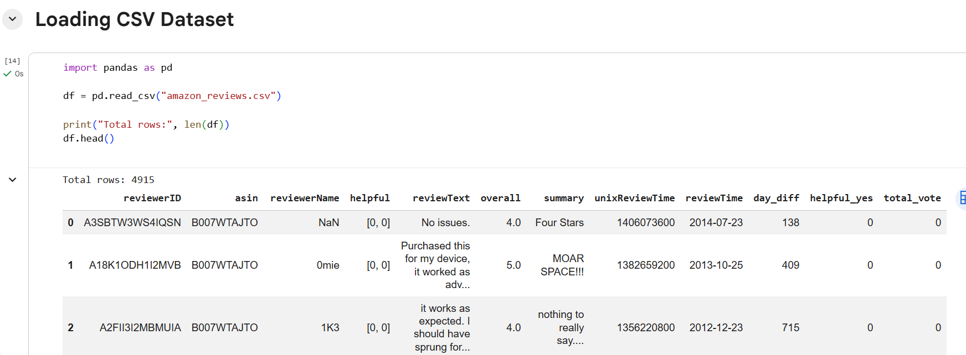
Figure 1: Loading CSV Dataset
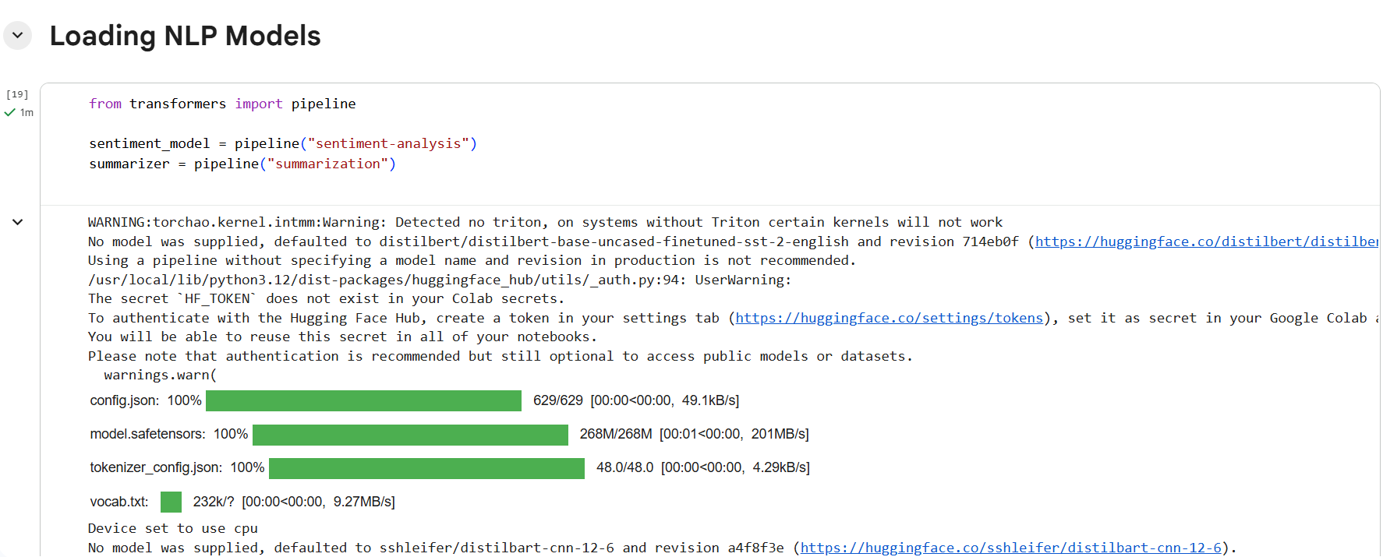
Figure 2: Loading NLP Models
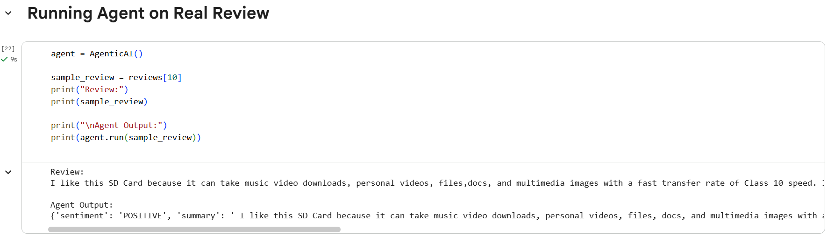
Figure 3: Agent Running on One Review
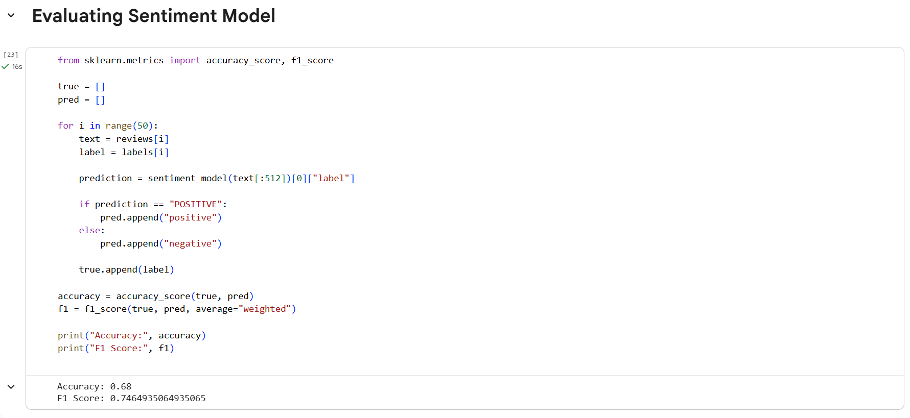
Figure 4: Evaluation Results
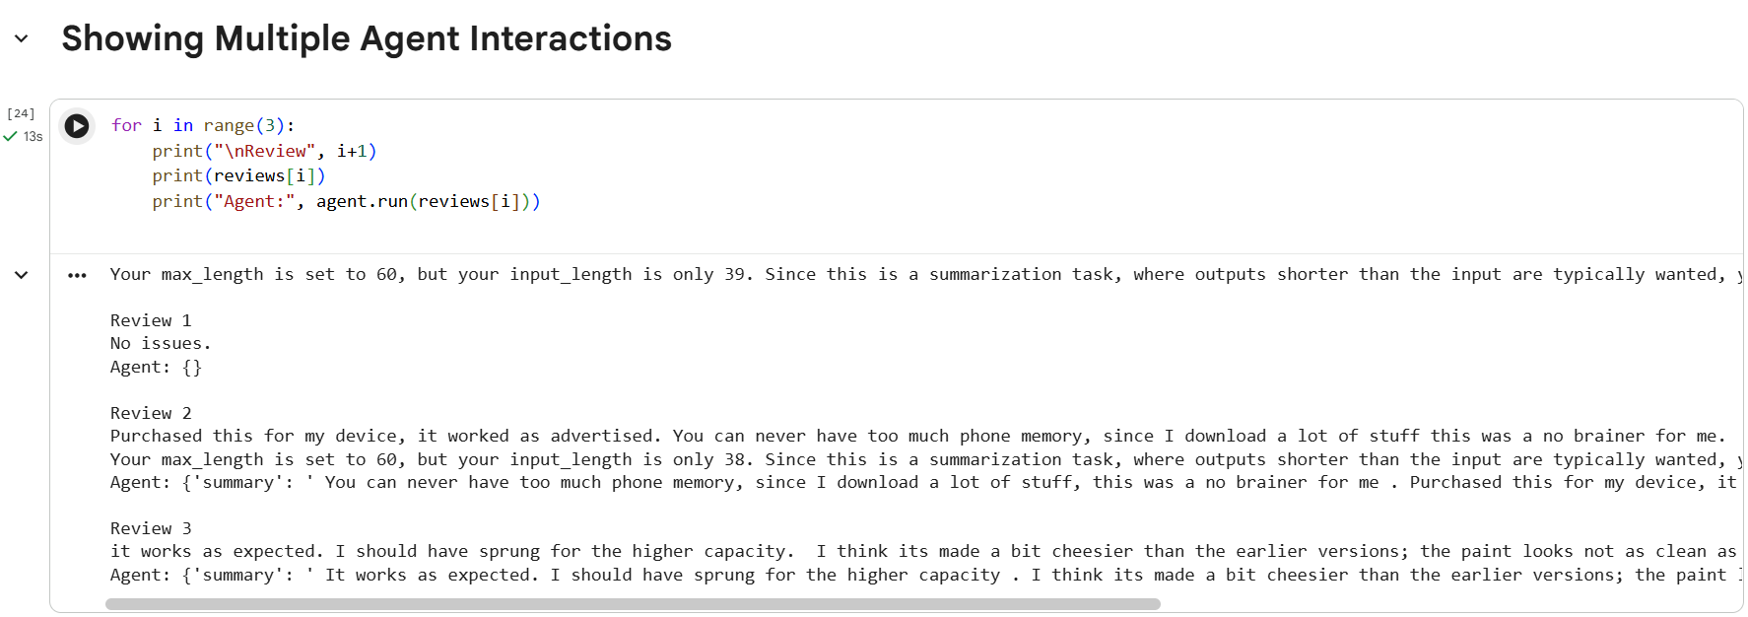
Figure 5: Interactions of Multiple Agents

